
The Mixed Nuts
Country Set Last revised on 2017.01.18
CTRY01-You Are My Sunshine(KVD).2016.07.17.pdf
CTRY02-Make The World Go Away(KVF).2016.07.17.pdf
CTRY02-Make The World Go Away(KVM).2016.07.17.pdf
CTRY03-King Of The Road(KV). 2016.08.28.pdf
CTRY04-Crazy(KV).2016.07.17.pdf
CTRY05-Have I Told You Lately That I Love You(KVD).2017.01.09.pdf
CTRY06-I Walk The Line(KV).2017.01.11.pdf
CTRY07-Blue Eyes Crying In The Rain(KVF).2016.07.17.pdf
CTRY07-Blue Eyes Crying In The Rain(KVM).2016.07.17.pdf
CTRY08-I'm Walkin' The Floor Over You(KV).2016.07.17.pdf
CTRY09-I Fall To Pieces(KVF).2016.07.17.pdf
CTRY09-I Fall To Pieces(KVM).2016.07.17.pdf
CTRY10-Folsom Prison Blues(KV).2016.07.17.pdf
CTRY11-Coal Miner's Daughter(KV).2017.01.09.pdf
CTRY12-I Can't Stop Loving You(KVF).2016.07.17.pdf
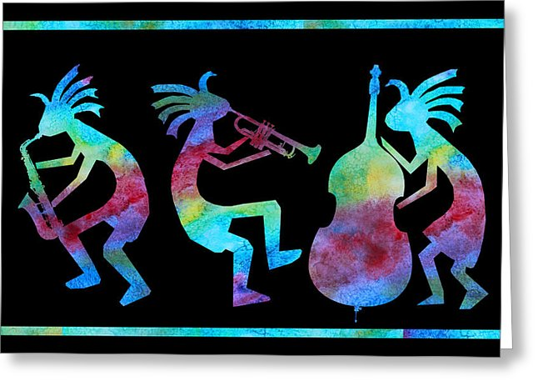
CTRY12-I Can't Stop Loving You(KVM).2016.07.17.pdf
CTRY13-Okie From Muskogee(KVD).2016.07.17.pdf
CTRY14-Stand By Your Man(KV).2016.10.02.pdf
CTRY15-Tennessee Waltz(KVF).2016.08.23.pdf
CTRY15-Tennessee Waltz(KVM).2016.08.23.pdf
CTRY16-Your Cheatin' Heart(KVD).2016.07.17.pdf
CTRY17-El Paso(KV). 2016.08.28.pdf
CTRY18-Walkin' After Midnight(KVM).2017.01.18.pdf
CTRY18-Walkin' After Midnight(KVF).2017.01.18.pdf
CTRY19-Ring Of Fire(KV).2016.12.31.pdf

CTRY20-Wabash Cannonball(KVF).2016.07.17.pdf
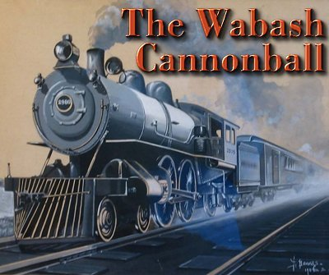
CTRY20-Wabash Cannonball(KVM).2016.07.17.pdf

